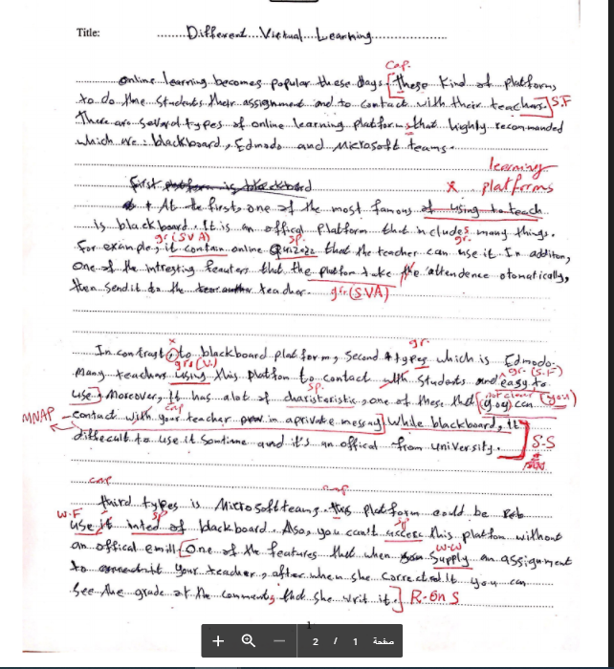

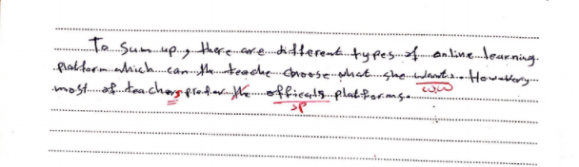

Symbol | Meaning
GR. | Grammar mistake
GR. (V.F)/ V.F | Wrong verb form
Gr( S.V.A) | Subject verb agreement
W.F | Word form
GR (T)/ T | Wrong tense
S.S | Sentence structure
WW | Wrong word choice
W. PH/ PH. S | Wrong phrase  Phrase structure is Wong
W. PRON | Wrong pronoun
MNAP | Meaning not accurately presented
M. PRON | Missed pronoun
PRO. REF | Pronoun reference
R ON S | Run on sentence
ART | Article
SF | Sentence fragment
MNC/ NOT CLEAR | Meaning not clear
WO | Wrong Word order
SP | Spelling
Cap | Capitalization
Pun | Punctuation marks
CONJ | Conjunction

